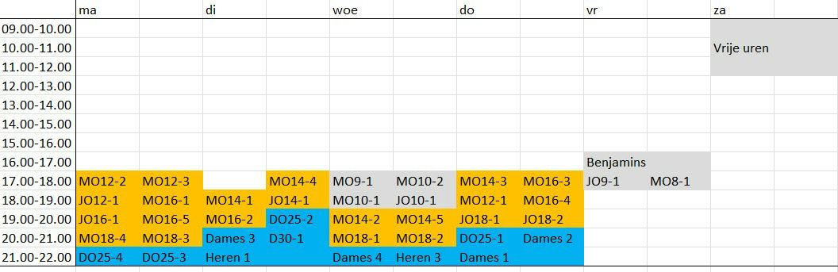
Schema zaaltrainingen 23/24

